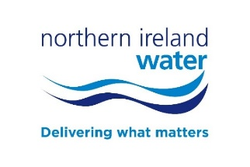
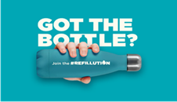

[Insert company logo]

Press Release

[Insert company name] Join the Refillution!

[Insert company name] are delighted to support Northern Ireland Water’s #Refillution campaign, aimed at encouraging everyone to commit to refilling a reusable water bottle with our world-class tap water and stop buying single use plastic bottles.

Northern Ireland uses 145 million single use plastic bottles every year. By switching to a reusable bottle, people can help turn the tide in helping to reduce plastic waste. Our drinking water is 99% pure and we want everyone to benefit from it.

Xxxxx / CE/ MD/Mayor/ says, “INSERT QUOTE…”

With drinking water now at the highest quality on record, staying hydrated and reducing plastic waste is a win-win for everyone.

Angela Halpenny, Northern Ireland Water Head of Environmental Regulation says, “We are delighted [Insert Business/organisation] are supporting our campaign, encouraging everyone to switch to refilling a reusable water bottle from the tap. The water industry has a strong focus on the environment and we are committed to tackling the problems caused by plastic bottles which block up our rivers and drains, and pollute our seas.”

Get involved! Just hashtag #Jointherefillution #Refillution @niwnews @JoinRefillution and start sharing with your friends!

For more information about the campaign visit www.niwater.com/refillution/

ENDS
Media enquiries to the NI Water Press Office on 028 9035 7695 or via email to press.office@niwater.com

Photo Caption:

