NON-RETURN TO SEWER APPLICATION FORM
To apply for an increased non-return to sewer allowance, please fully complete all sections of this form and return to:
Northern Ireland Water Limited PO Box 2376
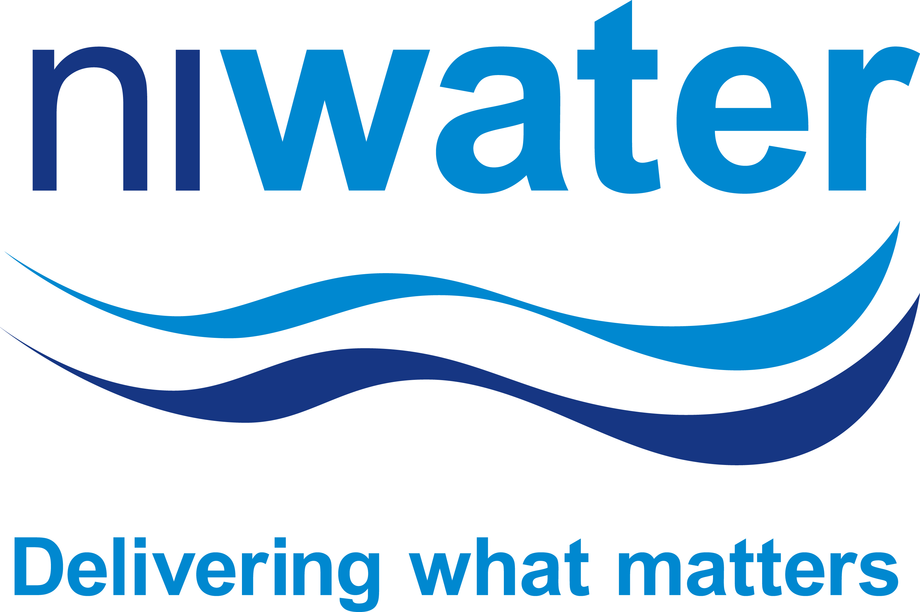
Belfast BT13 3DX

Background
The sewerage volumetric charge assumes that, on average, 5% of the metered water supplied to customers is not returned to a public sewer. This applies to all customers and is already reflected on your bill. However, if you occupy a non-domestic property and can demonstrate that more than 5% of the water supplied to your through your meter is not returned to a public sewer, please complete this form and return to the address above along with the associated fees.

Section A – Customer Details

Section B – Application Details and Data
Please confirm below whether you discharge trade effluent.
As defined by Article 199 of the Water and Sewerage Services Order (NI) 2006, trade effluent is:
- Any liquid, with or without particles of matter in suspension in the liquid, which is wholly or partly produced in the course of any trade or industry carried out on trade premises.
- In relation to trade premises, this means any such liquid which is produced in the course of any trade or industry carried out on those premises, but does not include domestic sewerage.
NB a non-return to sewer allowance does not apply to customers discharging a trade effluent except where a separate process also exists which uses water and discharges to a public sewer.
http://www.niwater.com/trade-effluent-charges/
For further information on trade effluent, visit our website:

Customer Name (as stated on bill)
Applicant name (if different)
Customer reference: (8 digits only; e.g. MC01234567/01)
Address – Number, Street
Address – Town
Address – Postcode
Contact Name
Daytime Telephone No. (include STD code)

Page 1 of 3
Our Ref: NRTS_1015_V0.2

TRADE EFFLUENT DECLARATION: Please tick A, B, C or D as applicable

A | I do not discharge a trade effluent but use a significant amount of water in production processes. A percentage of this water is subsequently not discharged to a public sewer.
B | I use water for irrigating recreational areas. A percentage of this water is subsequently not discharged to a public sewer.
C | I use a significant volume of water for other purposes. A percentage of this water is subsequently not discharged to a public sewer.
D | I do discharge a trade effluent but use a significant amount of water in a separate process. A percentage of this water is subsequently not discharged to a public sewer.

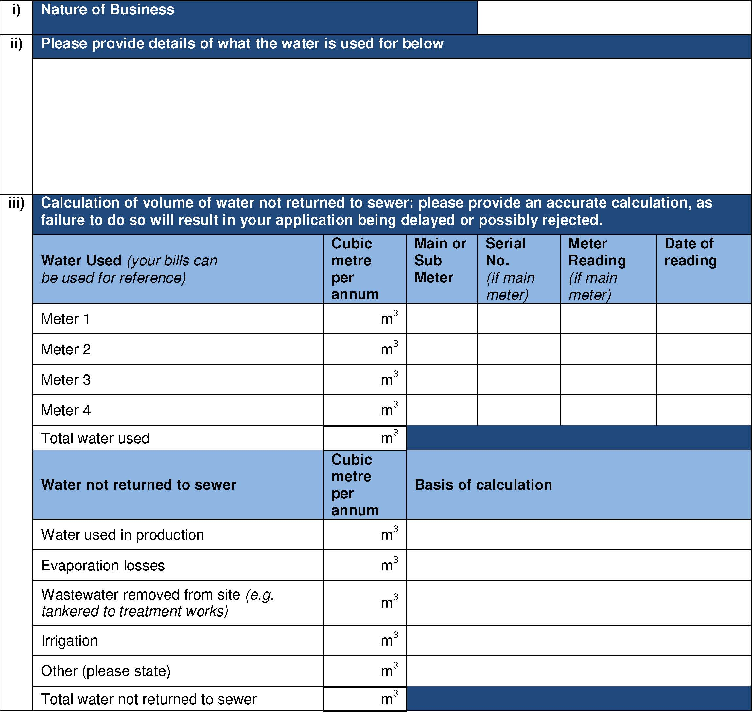
Page 2 of 3
Our Ref: NRTS_1015_V0.3
Access to Premises
By signing and returning this form, you agree to allow an authorised representative of Northern Ireland Water to visit the premises at any reasonable time to check the basis of this application. If we need to visit the premises to consider your initial application, we will let you know.

Please provide supporting documentation in order to assist validation of the figures provided above. If we are unable to calculate the allowance based on the information provided, you will be advised that a private sub-meter will be required to determine an accurate volume of water not returned to the sewer. This would have to be purchased and installed at your own expense. After installation, we would require 12 months of readings from the sub-meter before calculating any additional non-return to sewer allowance.

NB All decisions relating to this claim are at the discretion of Northern Ireland Water and are non-negotiable.
Before submitting your application, please ensure the following mandatory requirements have been included:
- Documentary evidence to support your claim
Supporting Documentation
I confirm that the information given on this form is correct, that I am an authorised representative of the company or account holder, and that I have provided the required supporting documentation.
I wish to apply for an increased Non-Return to Sewer Allowance in respect of the property described in Section A of this form.
Section C – Declaration
If your application is successful, any adjustment in charges will be made as outlined in the current Scheme of Charges*.
Adjustment of charges

Signature |  | Position in company
Print Name |  | Date (DD/MM/YYYY)

*Scheme of Charges can be found on our website http://www.niwater.com/your-bill-and-our-charges/
Page 3 of 3
Our Ref: NRTS_1015_V0.2

